**Step 1: Create a File Share**

1. Log in to the **AWS Management Console**.
2. Navigate to **AWS Storage Gateway**.
3. Select **Create File Share**.

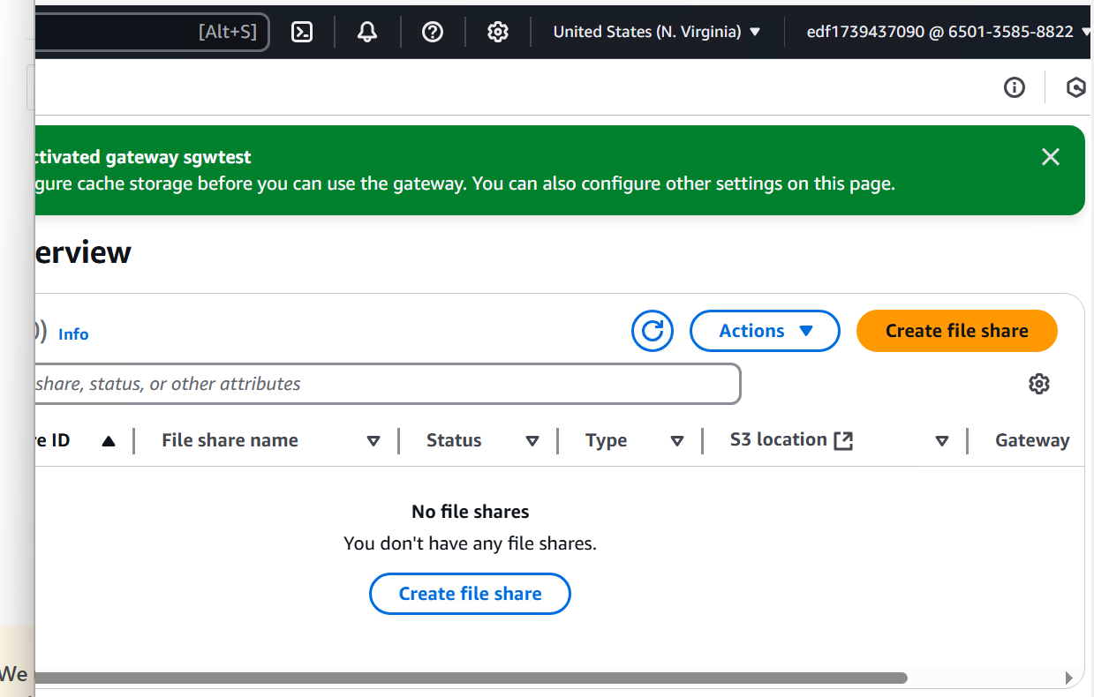

**Step 2: Choose SMB and Provide S3 Bucket Details**

1. Choose **SMB (Server Message Block)** as the file share type.
2. Provide the **S3 bucket name** where data will be stored.
   * If an S3 bucket is not created, create a new one before proceeding.

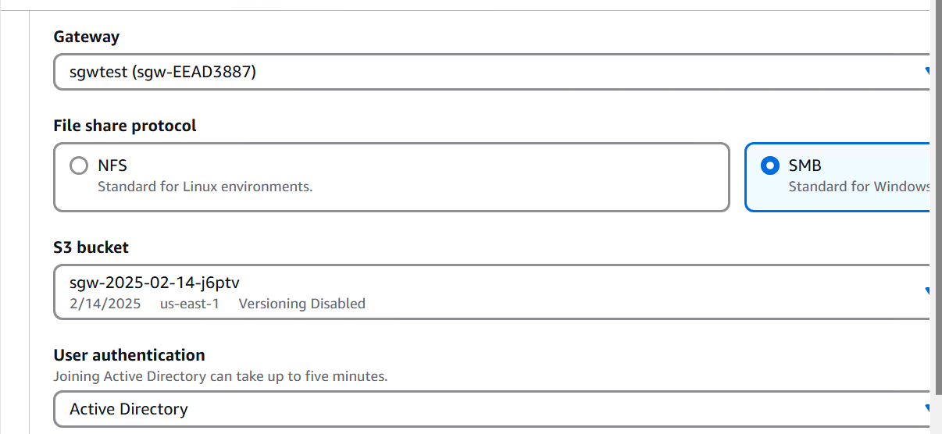

**Step 3: Configure Active Directory (AD) Settings**

1. Enter the **Active Directory (AD) details** provided by the trainer.
2. Ensure proper authentication settings are configured.

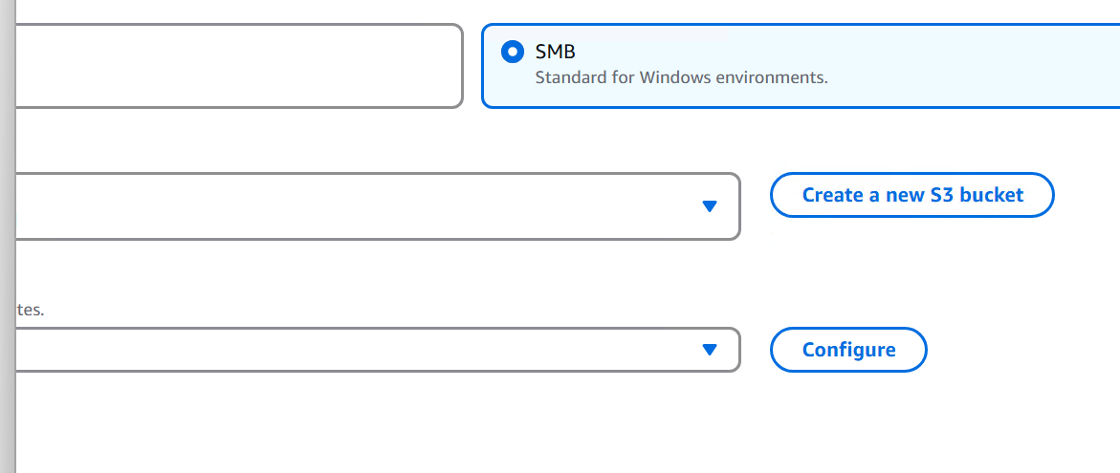

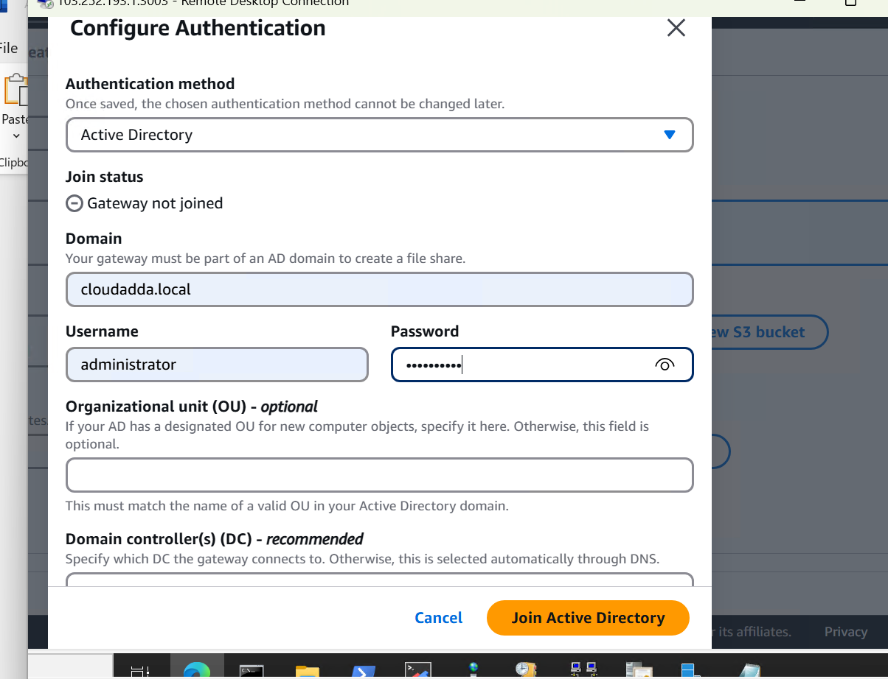

**Step 4: Complete File Share Setup**

1. Click on **Create File Share**.
2. Wait for the file share to be successfully created.

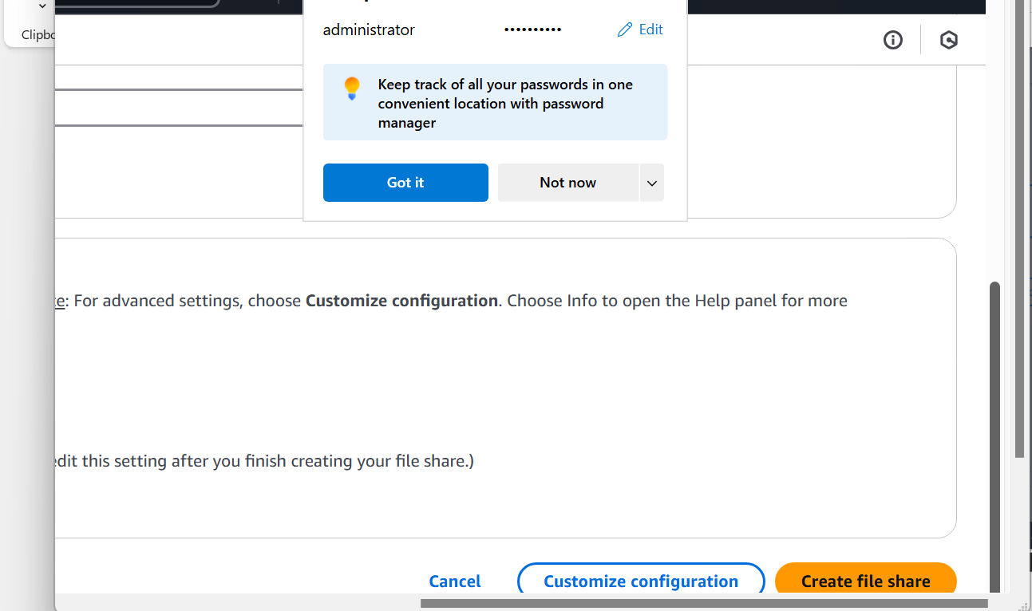

Command , which you need to run on windows system

net use [WindowsDriveLetter]: \\192.168.201.102\sgw-2025-02-14-gb7xq

**Step 5: Mount File Share on a Windows System**

1. Open the **Command Prompt** on a Windows machine.
2. Run the following command to map the network drive:

net use [WindowsDriveLetter]: \\192.168.201.102\sgw-2025-02-14-gb7xq

* + **Replace [WindowsDriveLetter] with an available drive letter (e.g., Z:).**
  + **Ensure the IP address (192.168.201.102) matches the assigned gateway IP.**

